Mobile app

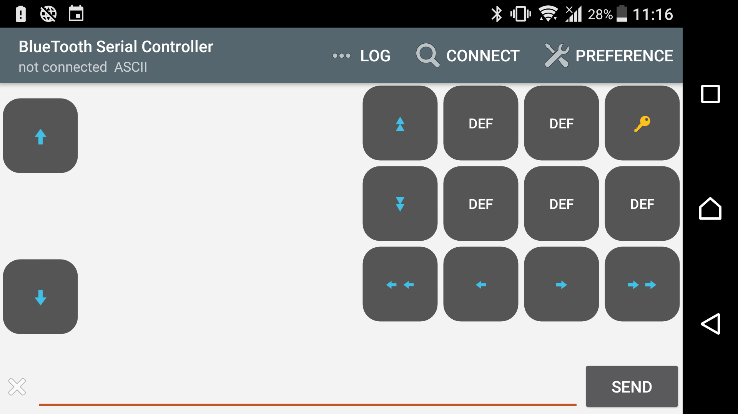

1-Designing the gui.

2-Making the layout.

3-Choosing the buttons command.